2019 - Tuckers Grave Inn Event /Campsite
T and C’s

We try to ensure that everyone who plans a party and if wanted also stays on our
campsite enjoys their visit.
For this reason we have complied a set of rules and guidelines which we expect everyone on site to abide by, come and have a coffee with us if you want to talk in more detail or give us a call.

Your Event

- When booking the party / event a deposit is required to secure and confirm your booking of £100 per night of function you’re planning.

- We expect your guest to behaviour in an appropriate manner, you are responsible for their behaviour

- The deposit taken can be held if party organisers do not control the behaviour or administer the guidelines laid out in this document.

- Tuckers Grave Inn has a PRS licence so music can be played within the barn to an audience.

- A live band can be booked or staff can assist with making suggestions on groups which are on our listings

- Sound Limit; to prevent any disturbance for our surrounding neighbour there is sound limiting system in place which will cut the power to the PA systems & Amplifiers that go above the appropriate levels of sound (95 db). The 3 light system will be shown during the initial overview of the venue.

- Mobile monitoring beyond this system will also be made during any event to ensure are not effecting local residents with noise pollution, this may be fed back to the organisers to adjust or change activities and needs to be followed, if not this may affect deposits paid and ultimately the power being isolated.

- The performance must end at 11pm, the sound limit system has a
time control built in to control this.

- The control for power once isolated is within a closed area and is not accessible once isolated by staff in the unfortunate occurrence of this as an outcome.

- Flashing coloured lighting to boost performance setting can be switched on if requested.

- Only drink purchased from the premises may be consumed in the Barn/pub garden (see map), anyone found bringing their own drink in this area may be asked to leave, this may also affect deposits if organiser does not control once made aware of the situation as the pubs licence may be affected if ignored. Drinking in the camping areas is accepted.

- The barn can be decorated as you like you can have access from midday of the day booked to begin you preparations. No permanent sprays / alike can be used. Whatever you put up, you take down to leave the venue ready for the next happy revellers.

- The bar closes at 11pm

- No glassware from the pub to be taken into the camping fields or Barn
Eco friendly cups are available to purchase at £1 each, these are
refundable, no bulk refunds of cups beyond 2 can be offered per
person.
- You will be made aware FIRE SAFETY ARRANGEMENTS, you and staff will be responsible for this.

- No smoking inside any of the facilities, the designated smoking areas are the Beer Gardens

- We do not provide exclusivity to any event, we will not advertise it but you need to be aware that people who may be camping / having a pint in the pub may wander out to listen to your music and would appreciate you to welcome them.
Events to date have enjoyed the sociable interaction with it boosting the
positivity of their party.

- Food can be provided, a BBQ or other if requested, alternatively you can arrange your own food to meet with your requirements.

- We do not allow fireworks

- Dogs must be kept under control and on a lead at all times. Please ensure that any dog mess is cleaned up even when taking your dog for a walk around the campsite. This is in the interest of hygiene for everyone. Bag it and Bin it

- The sockets within the barn are on a timer so may not work during the day due to misuse previously, this can be adjusted by request.

- A floodlit footpath from the pub exists and we would like you to use rather than squeeze between cars in the car park putting yourself at risk with car movements. The area is floodlit but better to be safe than sorry.

To move your event forward email us with your needs and confirm you have understood the event T and C’s, check the date and off we go!

Camping in conjunction with a party.

- You can request an area to be dedicated to your party by request. This area will be the area shown on the map in front of the barn on the far side of the stream Yellow and Orange

- Payment can be made prior by organiser for numbers to be present, approx. numbers will be needed to designate appropriate areas for us to set aside, a deposit will be needed to secure the required area.

- ON ARRIVAL campers are to report to the Pub before setting up.
Late arrivals should report to the pub as soon as it opens

- Tags must be displayed at all times

- Camp fires are permitted but only in raised fire pits.

- Bar-B-Qs are permitted provided the bbq is on a stand to avoid burning the grass
- The use of mobile generators is strictly prohibited

- Please Respect our neighbours, no noise after 11pm

- Speed limit of 5mph is mandatory in the interest of everyone's safety especially children playing.

- You are responsible for your children’s actions.

- Keep your camping area clean and tidy. Do not drop litter around the site. It's not only messy but dangerous to wildlife and farm animals. Please treat the land, facilities and amenities on site with respect and care so that other guests may continue to enjoy them. In the event that you notice damage to any facilities or amenities please report it to the Pub immediately so that we can take the appropriate action.

- All persons using the site and its facilities do so at their own risk. No responsibility is accepted by the proprietors for personal injury or inconvenience, loss or damage to personal property including vehicles

- We take care that the details within this are accurate, but we reserve the right to amend details without prior notice.

- Emergency contact numbers 07976897743 / 07834974498

How much will your event cost you at Tuckers?

Deposit required on barn at time of booking ----------------- £100 per night
(The deposit will be returned after the event subject to T & C’s listed)

Cost of barn per night with bar ---------------------------------- £150 per night
(This includes, bar, staffing and lights to T & C’s listed)
Note you may apply for a TENS licence for your event, please speak to us first to ensure this is acceptable on your required dates.

Camping / Vans ---------------------------------------------------- £5 per person
To have allocated camping for the numbers of people which are attending your party we will need to know numbers as stated in T & C’s.
We would require 50% deposit for the number request to allow us to secure this area for you.
(Note several electrical hook ups are now available at an extra charge of £10 per unit)

Rent the 8 person Accommodation in Tuckers if you don’t fancy canvas for the night, ask for more details or check dates on Air B&B and make your reservation.

Skittles for your party -------------------------------------------- £30 per night
Bring your own sticker up or we can supply one just let us know

Food whilst skittling,

You can have Chilli or Stew for a hot option -------------- £4 per person
Or a Ploughmans ——-------- £4 per person

Booking Confirmation
No booking is fixed until deposits have been paid, you will have booking confirmation once payment have been made.

Apologies…..
Our site is presently under development. There are plans for new a new shower and toilet block summer 2020next year. Unfortunately until then our only option are portaloos. These are emptied every Tuesday
In the event they are full, we have 24 hour toilets at the pub
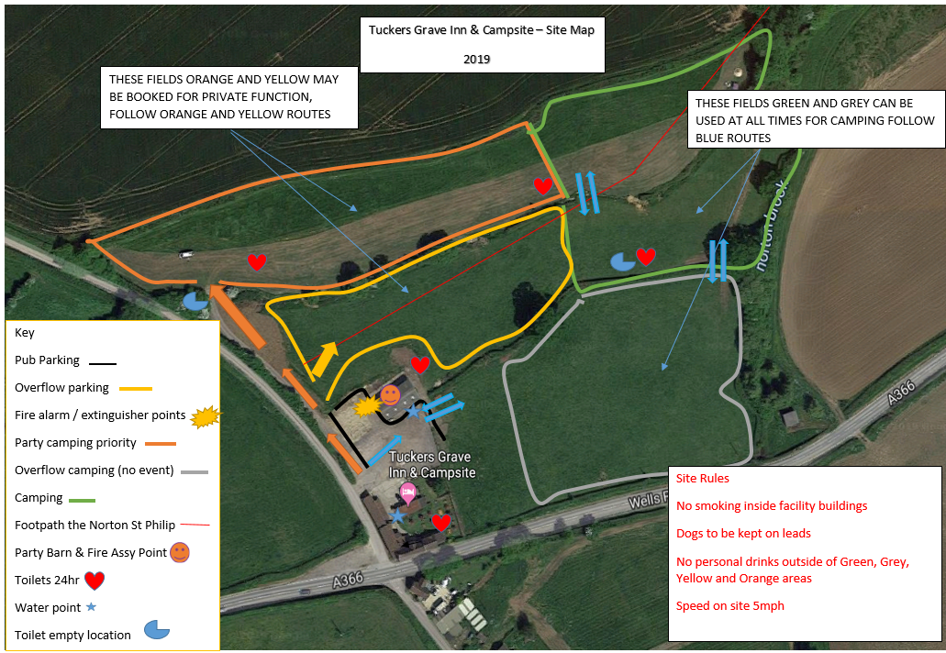
If you fancy a wander off site you can wander to Norton St Philip for lunch as highlighted below or take a wander to the Lavender Farm for cream teas in the summer!